1. For the following data sets build decision trees using ID3 algorithm, whether a person buys a computer or not.

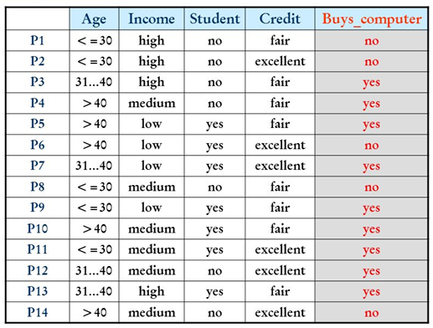

1. For the following data sets build decision trees using ID3 algorithm, whether a person is a defaulted borrower or not.

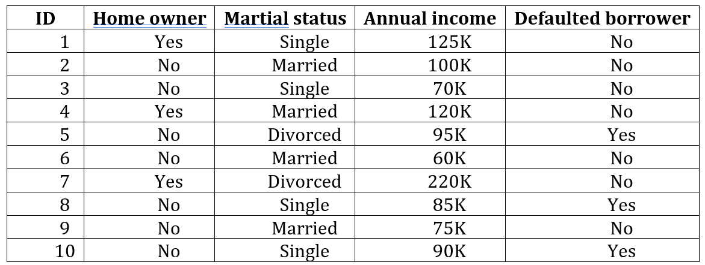

1. For the following data sets build decision trees using ID3 algorithm, to predict a person’s decision of his/her activities in weekend.

